Lab 6: Convolution-II

Hiba Aiman Ali

ha09269

February 13th, 2025

Lab Report

Name: Hiba Aiman Ali | Student ID: 09269
Task 1:
Code:
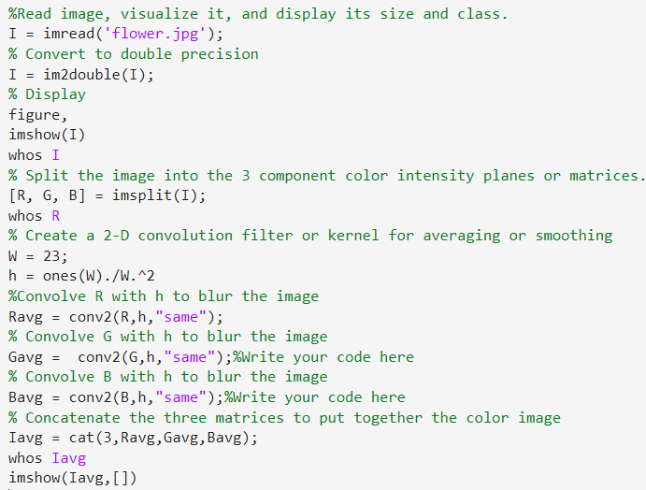
Comments:
Increasing W in the code just results in a blurrier image and the corners are getting this shadow/vignette sort of effect more with the increase in W in the code, because of convolution around the borders.
Results:
The final result was shown in the LiveScript in such manner:
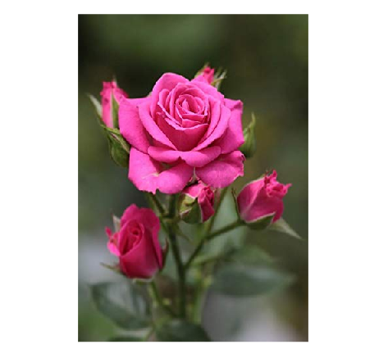 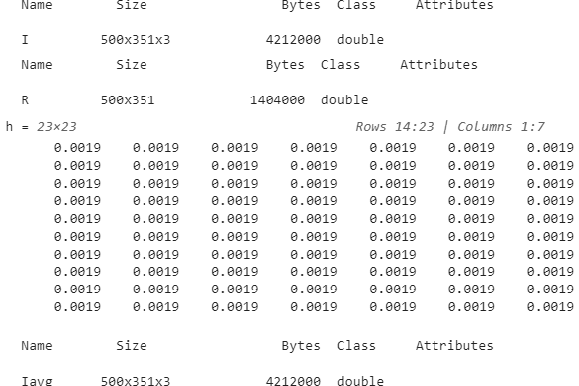 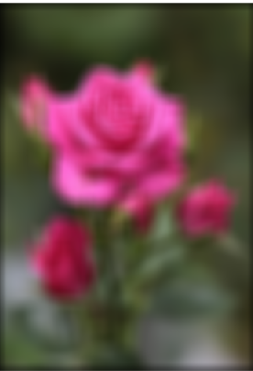

Task 2:
Code:
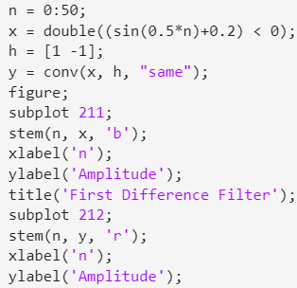
Comments:
The first difference filter detects transitions by computing the difference between consecutive values in a signal. Applied to x[n], it highlights changes, making it useful for edge detection. By plotting both signals, we see how the filter enhances transitions, a key concept in image processing and barcode detection.
Results:
The final result was shown in the LiveScript in such manner:
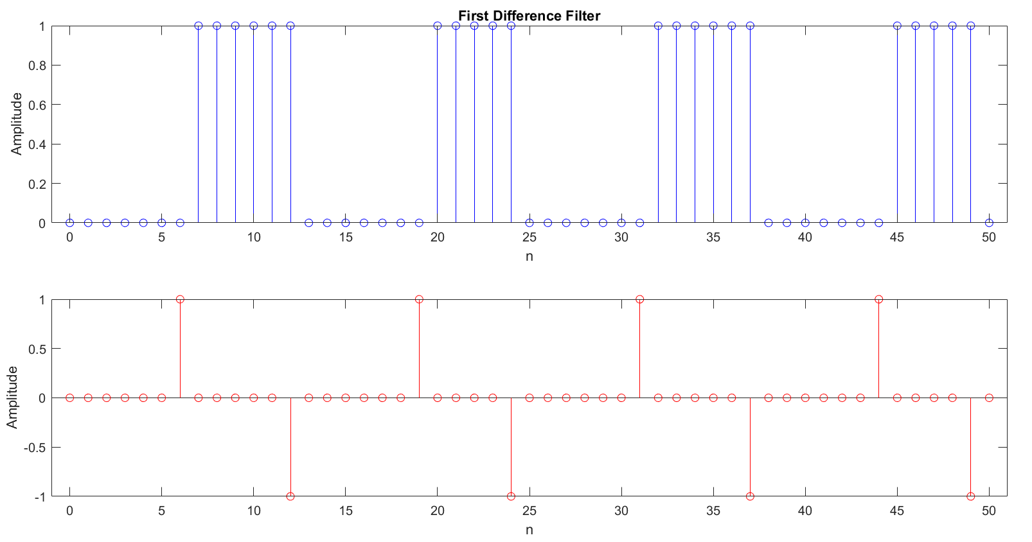

Task 3:
Code:
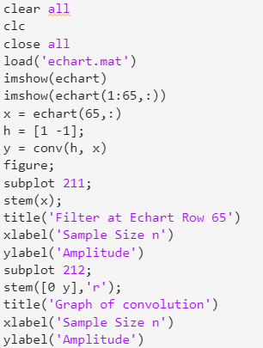

Comments:
The 0 (zeros) represent the white pixels, while the 255 (ones) represent the black pixels in the row. Any non-zero value in the output signal will represent a color whose shade is between the two extremes: white and black.
Results:

The final result was shown in the LiveScript in such manner:
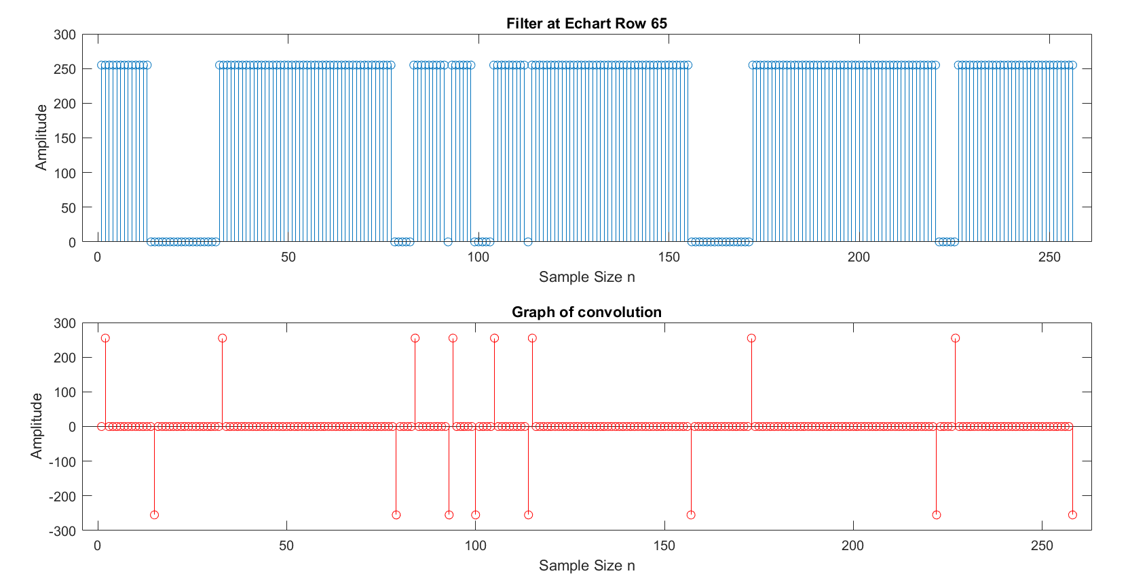
Task 4:
Code + Comments:
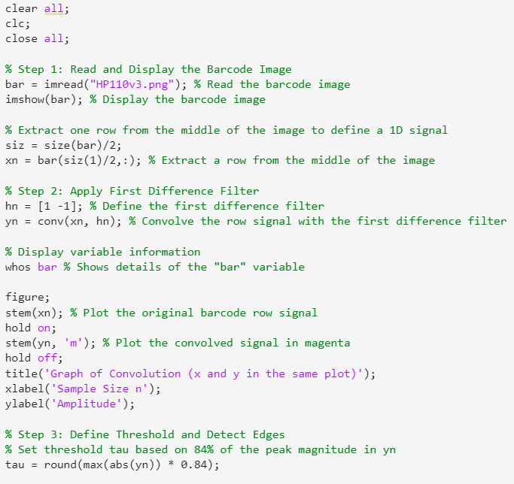
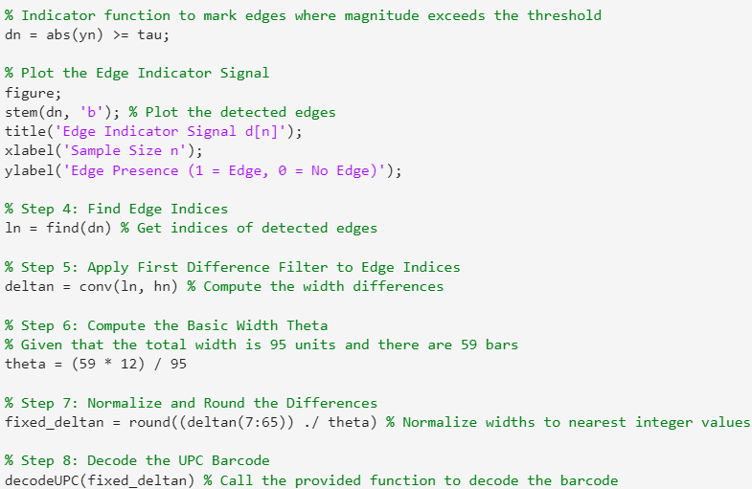
Results:
The final result was shown in the LiveScript in such manner:
Step 2:
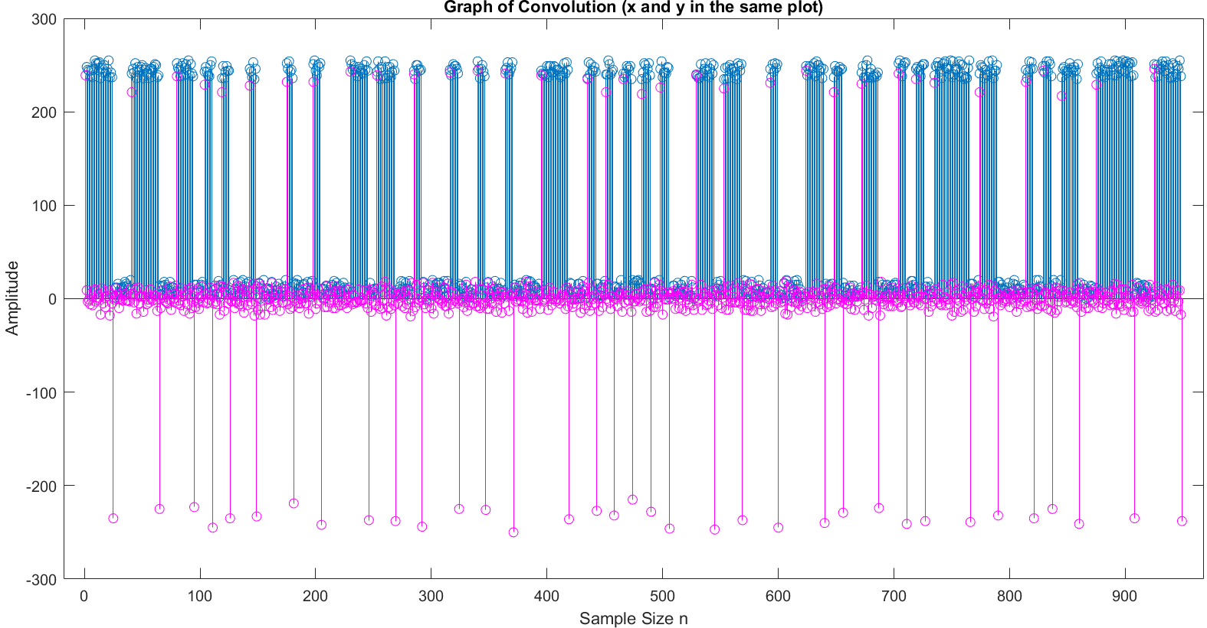
Step 3:
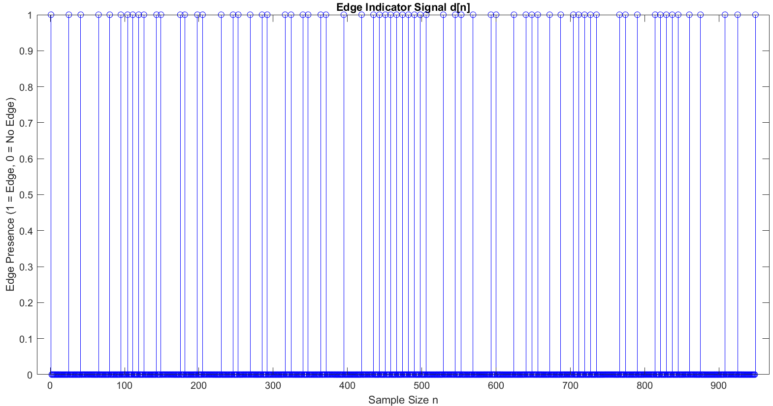
Step 4-8:
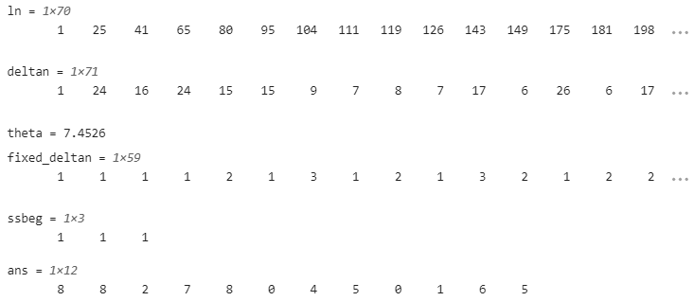

Lab Evaluation Assessment Rubric

